**Urban Asset Restoration: Implementing Accidental Damage Reimbursement for Municipal Properties using Power BI**

**Introduction:**

Urban Asset Restoration (UAR) recognizes the critical importance of maintaining municipal properties in urban environments. Accidental damages to these assets can result in significant financial burdens for both local governments and taxpayers. To address this challenge, UAR proposes the implementation of an Accidental Damage Reimbursement system using Power BI, a powerful business intelligence tool. By leveraging Power BI's data visualization and analytics capabilities, UAR aims to streamline the process of identifying, documenting, and reimbursing accidental damages incurred by municipal properties.

Through the utilization of Power BI, UAR intends to create a centralized platform that consolidates data related to accidental damages across various municipal properties. This platform will enable efficient tracking of incidents, including details such as location, type of damage, and cost of repairs. By aggregating this information, local governments can gain valuable insights into prevalent issues affecting their assets, allowing for targeted interventions and preventive measures to mitigate future damages.

Furthermore, the implementation of an Accidental Damage Reimbursement system powered by Power BI offers transparency and accountability in the management of municipal properties. By providing stakeholders with access to real-time dashboards and reports, UAR aims to foster greater trust and confidence in the handling of public resources. Additionally, by analyzing trends and patterns in accidental damages, local governments can make data-driven decisions to optimize resource allocation and prioritize maintenance efforts, ultimately enhancing the overall resilience and sustainability of urban infrastructure.

**Scenario 1: Identifying High-Risk Areas**

Through Power BI analysis, a city discovers specific neighborhoods prone to accidental damages, leading to targeted infrastructure upgrades and maintenance efforts, ultimately enhancing safety.

**Scenario 2: Proactive Maintenance Planning**

Power BI analytics reveal trends in accidental damages to public parks, enabling the implementation of proactive maintenance strategies, resulting in improved park aesthetics and visitor experiences.

**Scenario 3: Streamlined Reimbursement Process**

Power BI centralizes the reimbursement process for accidental damages across city departments, facilitating faster claim processing, reducing administrative overhead, and enhancing transparency in resource management**.**

**Technical Architecture:**

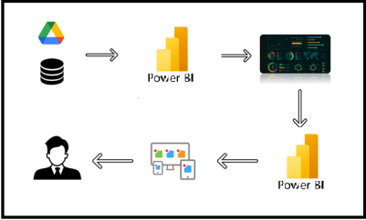

**Project Flow**

To accomplish this, we have to complete all the activities listed below,

* Data Collection
  + Collect the dataset,
  + Connect Data with Power BI
* Data Preparation
  + Prepare the Data for Visualization
* Data Visualizations
  + Visualizations
* Dashboard
  + Responsive and Design of Dashboard
* Report
* Report Creation
* Performance Testing
  + Utilization of Data Filters
  + No. of Calculation fields
  + No. of Visualizations/Graphs
* Project Demonstration & Documentation
  + Record explanation Video for project end to end solution
  + Project Documentation-Step by step project development procedure

**Milestone 1: Data Collection & Extraction from Database**

Data collection is the process of gathering and measuring information on variables of interest, in an established systematic fashion that enables one to answer stated research questions, test hypotheses, evaluate outcomes and generate insights from the data.

**Activity 1: Downloading the dataset**

Please use the link to download the dataset: [Link](https://data.world/harishkgarg/indian-students-abroad-mar-2017)

**Activity 1.1: Understand the data**

Data contains all the meta information regarding the columns described in the CSV files

**Column Description of the Dataset:**

* Index: Unique identifier for each record.
* Recoup ID: Identification number for the recoupment process.
* Source Description: Description of the source of the accident.
* Accident Date: Date when the accident occurred.
* Police Report ID: Identification number for the police report filed for the accident.
* Location: Location where the accident took place.
* Date Received: Date when the accident report was received.
* Close Date: Date when the accident case was closed.
* Status: Current status of the accident case.
* Latest Action Description: Description of the latest action taken on the accident case.
* Borough: Borough where the accident occurred.
* Precinct ID: Identification number for the precinct associated with the accident location.
* Description: Description of the accident.
* Unit Description: Description of the unit involved in the accident.
* Company Name: Name of the company involved in the accident.
* Request Amount: Amount requested for recoupment.
* Has Admin Fee: Indicates whether an administrative fee is applicable.
* Admin Fee: Administrative fee associated with the accident recoupment.
* Paid Amount: Amount paid for the accident recoupment.

**Milestone 2: Data Preparation**

**Activity 1: Prepare the Data for Visualization**

Preparing the data for visualization involves cleaning the data to remove irrelevant or missing data, transforming the data into a format that can be easily visualized, exploring the data to identify patterns and trends, filtering the data to focus on specific subsets of data, preparing the data for visualization software, and ensuring the data is accurate and complete. This process helps to make the data easily understandable and ready for creating visualizations to gain insights into the performance and efficiency. Since the data is already cleaned, we can move to visualization.

3.1: Data Loading

[Link](https://drive.google.com/file/d/1WvH3SLRkkbHTjLzpz3z35pzejrHH3Hnc/view?usp=drive_link)

3.2 Data Cleaning

[Link](https://drive.google.com/file/d/1F8zQ2l-6xO7cwYZ12gkHR6VwuXuanBKz/view?usp=drive_link)

**Milestone 3: Data Visualization**

Data visualization is the process of creating graphical representations of data to help people understand and explore the information. The goal of data visualization is to make complex data sets more accessible, intuitive, and easier to interpret. By using visual elements such as charts, graphs, and maps, data visualizations can help people quickly identify patterns, trends, and outliers in the data.

**Activity 1: Accident Damage Recoupment for City-Owned Property**

**Activity 1.1: Total Request Amount**

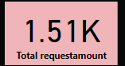

**Activity 1.2: Total Amount Outstanding**

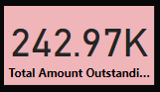

**Activity 1.3: Average Request Amount**

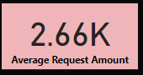

**Activity 1.4: Total Requests**

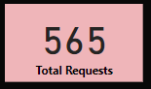

**Activity 1.5: Total Paid Amount**

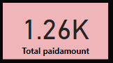

**Activity 1.6: Total Admin Fee**

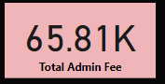

**Activity 1.7: Accident Year**

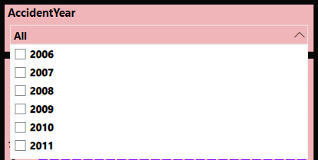

**Activity 1.8: Count Of Country By Admin Fee**

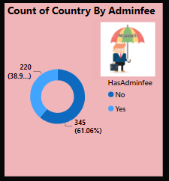

**Activity 1.9: Total Requests By Accident Year**

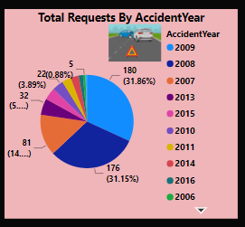

**Activity 1.10 : Count of Location By Accident Date**

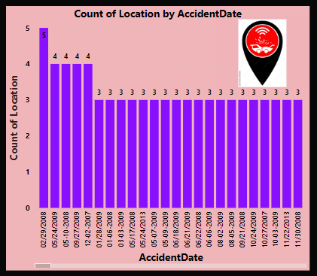

**Activity 1.11 : %GT Total Request Amount and Total Requests by Accident Date**

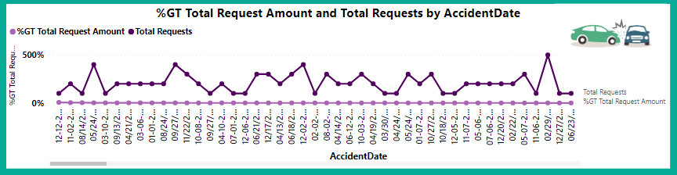

**Activity 1.12 : Sum Of Request Amount by Accident Date**

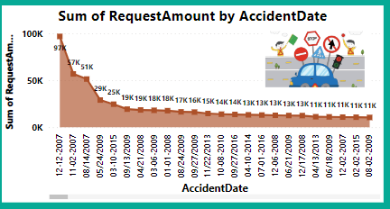

**Activity 1.13 : Total Paid Amount**

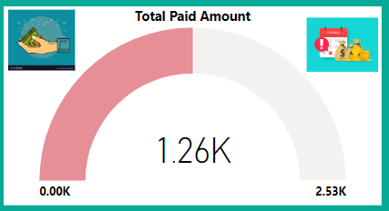

**NOTE:** Video Explanations for the above Visualizations are in Dashboard and Report sections.

**Milestone 4: Dashboard**

A dashboard is a graphical user interface (GUI) that displays information and data in an organized, easy-to-read format. Dashboards are often used to provide real-time monitoring and analysis of data and are typically designed for a specific purpose or use case. Dashboards can be used in a variety of settings, such as business, finance, manufacturing, healthcare, and many other industries. They can be used to track key performance indicators (KPIs), monitor performance metrics, and display data in the form of charts, graphs, and tables.

**Activity 1- Responsive and Design of Dashboard**

**Explanation video link:**

[Link](https://drive.google.com/file/d/1HhgjxL931yyiKjaIKmBP3Z5Vb1Up_xOv/view?usp=drive_link)

**Dashboard:**

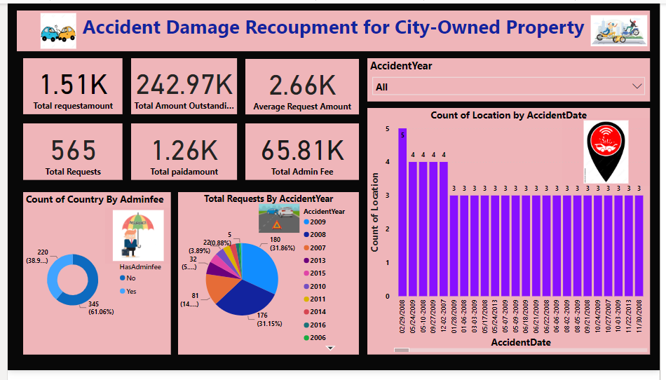

**Milestone 5: Report**

A report is a comprehensive document that provides a detailed and structured account of data analysis, findings, and insights. It is typically used for in-depth analysis, documentation, and communication of results. Reports are suitable for a diverse audience, including decision-makers, analysts, and stakeholders who need a comprehensive understanding of the data.

**Activity 1: Design of Report**

Designing a report in Power BI involves connecting to data sources, creating visualizations like charts and graphs, customizing their appearance and interactivity, organizing them logically on the canvas, formatting elements for consistency and clarity, and optionally creating dashboards for a summarized view. Throughout the process, it's essential to consider the audience's needs and ensure the report effectively communicates insights from the data. Finally, iterate based on feedback to continually improve the report's design and usefulness.

**Explanation video link:**

[Link](https://drive.google.com/file/d/1Y_W2ullXTVuQFgTsAD7VrDQVytX97Z4d/view?usp=drive_link)

**Report:**

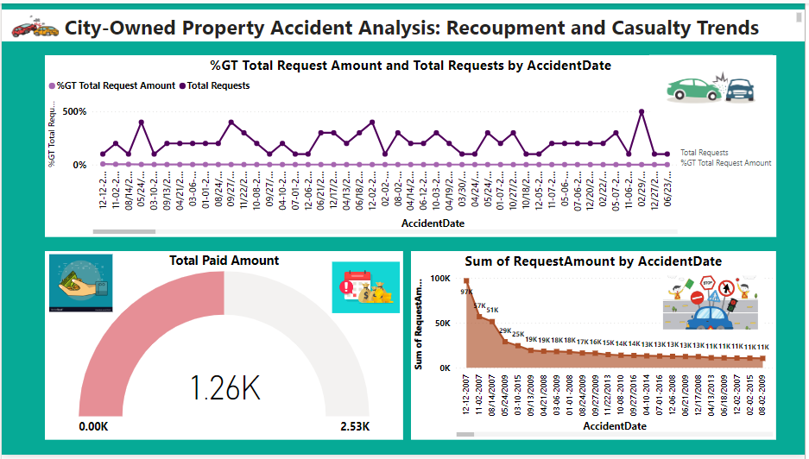

**Milestone 6: Performance Testing**

**Activity 1: Amount of Data Loaded**

"Amount of Data Loaded" refers to the quantity or volume of data that has been imported, retrieved, or loaded into a system, software application, database, or any other data storage or processing environment. It's a measure of how much data has been successfully processed and made available for analysis, manipulation, or use within the system.

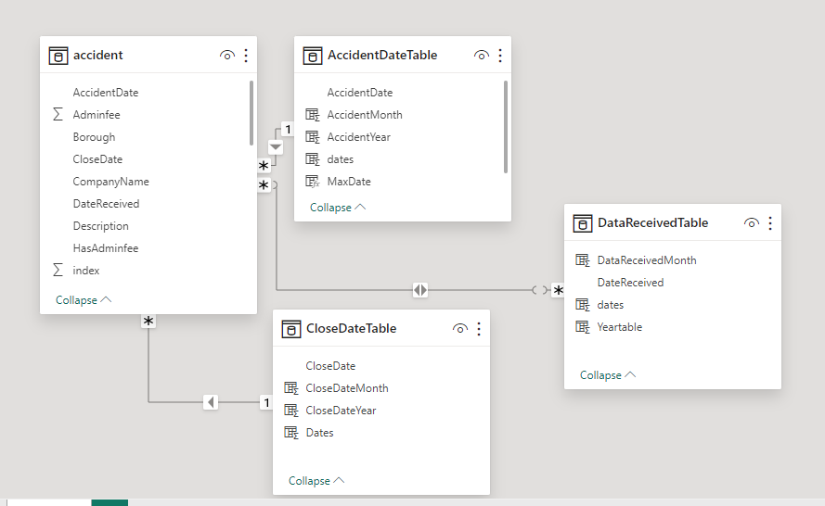

**Activity 2: Utilization of Filters**

"Utilization of Filters" refers to the application or use of filters within a system, software application, or data processing pipeline to selectively extract, manipulate, or analyze data based on specified criteria or conditions.

**Activity 2.1: Selected “Accident Year” as a Filter**

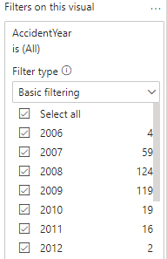

**Activity 3: No of Calculation Fields**

**Activity 3.1: Measure**

In Power BI, a measure is a calculation based on data in your dataset. Measures are created using DAX (Data Analysis Expressions), a formula language that allows you to perform calculations, create aggregations, and define business logic. Measures can perform various functions such as summing values, calculating averages, counting occurrences, or performing complex calculations based on conditions.











**Activity 4: No of Visualizations/ Graphs**

1. Total Request Amount
2. Total Amount Outstanding
3. Average Request Amount
4. Total Requests
5. Total Paid Amount
6. Total Admin Fee
7. Accident Year
8. Count of Country by Admin Fee
9. Total Requests by Admin Fee
10. Count of Location by Accident Date
11. %GT Total Request Amount and Total Requests by Accident Date
12. Sum of Request Amount by Accident Date

**Milestone 7: Project Demonstration & Documentation**

Below mentioned deliverables to be submitted along with other deliverables

**Activity 1: - Record explanation Video for the project's end-to-end solution**

**Activity 2: - Project Documentation-Step by step project development procedure**

Create document as per the template provided